January 2024 is the twentieth annual National Stalking Awareness Month (NSAM), a call to action to recognize and respond to this traumatic and dangerous victimization. Use this toolkit to post to social media daily during January. Download graphics sized for Facebook, Instagram, and Twitter—as well as account banners, email signatures, and virtual meeting backgrounds—on our website. Stalking awareness is always important, so follow us on social media @FollowUsLegally and share our posts year-round!
January 2024 |  | Image | Caption / Text
1 | Mon | 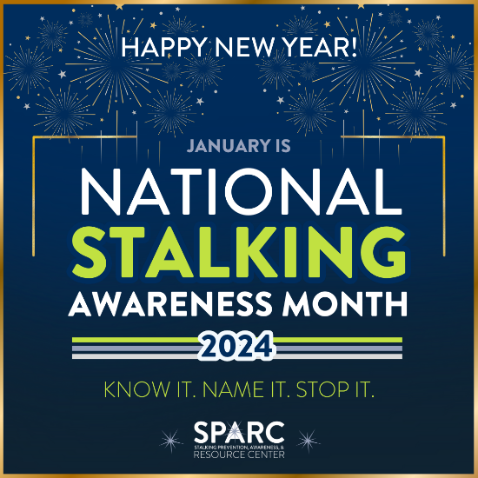  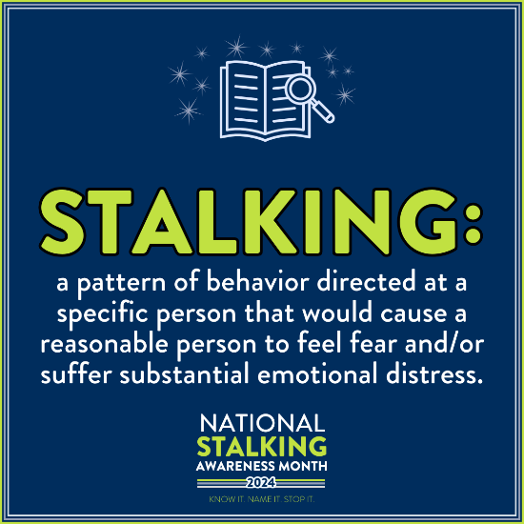 | The 20th annual National Stalking Awareness Month starts today! Please amplify our call to KNOW IT, NAME IT, and STOP IT! Resources available to learn more and spread the word at https://www.stalkingawareness.org/stalking-awareness-month-2024/ #KnowItNameItStopIt #NSAM2024
2 | Tues | 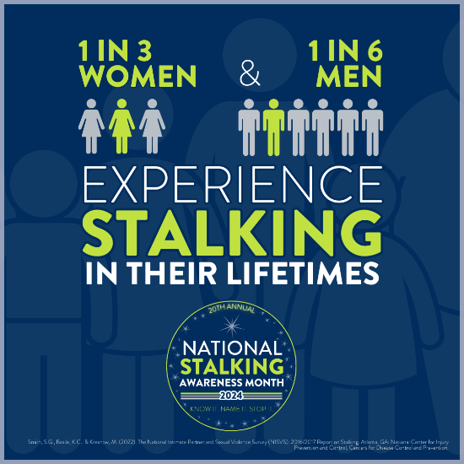 | Stalking is a prevalent victimization. Despite stalking rates similar to those of intimate partner and sexual violence, few resources exist to support victims and survivors of stalking. #KnowItNameItStopIt #NSAM2024
3 | Wed | 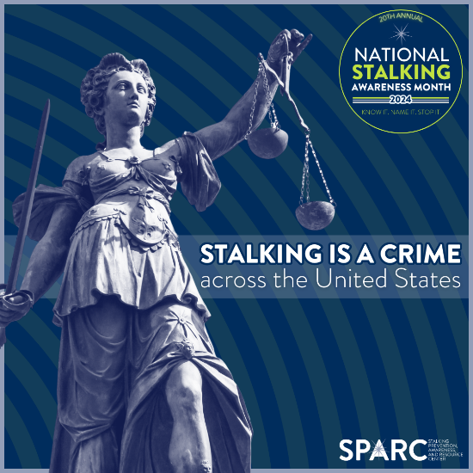 | Stalking is illegal in all U.S. states and territories. Engaging in stalking behaviors is a criminal offense, and offenders must be held accountable. Learn more about your jurisdiction’s stalking laws at https://www.stalkingawareness.org/map/ #KnowItNameItStopIt #NSAM2024
4 | Thurs | 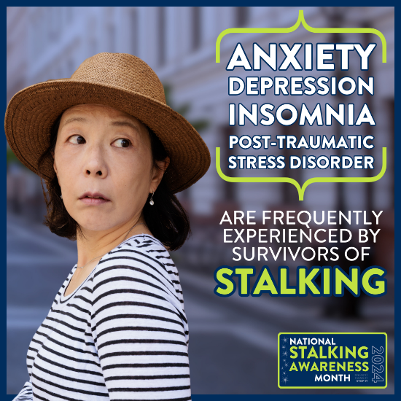 | “Always looking over my shoulder.” “I never trust that it’s really over.” “I don’t think I’ll ever feel safe.” Stalking is a traumatic victimization, and survivors often experience both short-term and lifelong mental health impacts. Learn more about getting help at https://www.stalkingawareness.org/what-to-do-if-you-are-being-stalked/ #KnowItNameItStopIt #NSAM2024
5 | Fri | 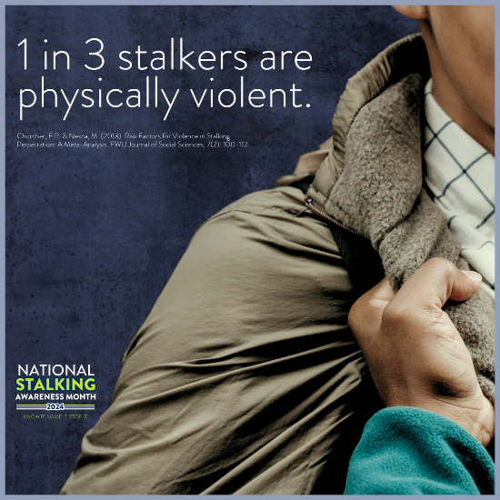 | Stalking is dangerous and often co-occurs with physical violence and sexual violence. #KnowItNameItStopIt #NSAM2024
6 | Sat | 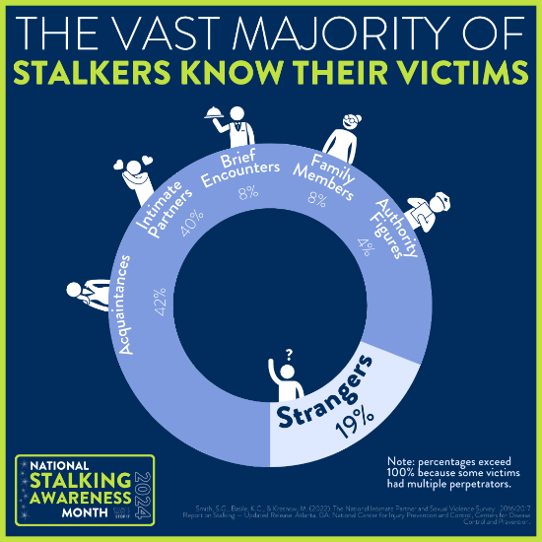 | Many people imagine stalkers as shadowy strangers or secret admirers. In reality, most stalkers are intimate partners or acquaintances. #KnowItNameItStopIt #NSAM2024
7 | Sun | 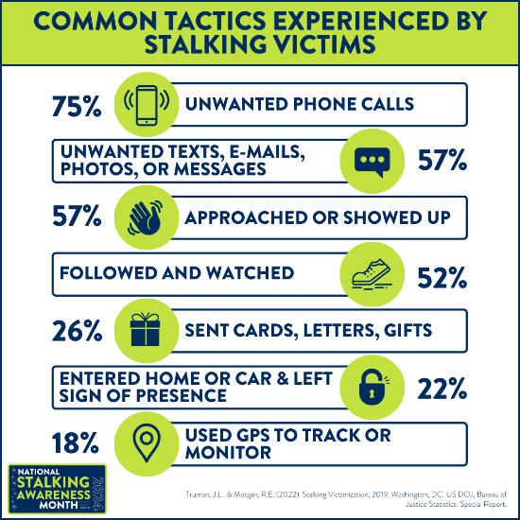 | Stalking is more than following, watching, and waiting. Most stalkers use multiple tactics to surveil, contact, sabotage, threaten, and otherwise scare their victims—and many use both online and in-person tactics. #KnowItNameItStopIt #NSAM2024
8 | Mon | 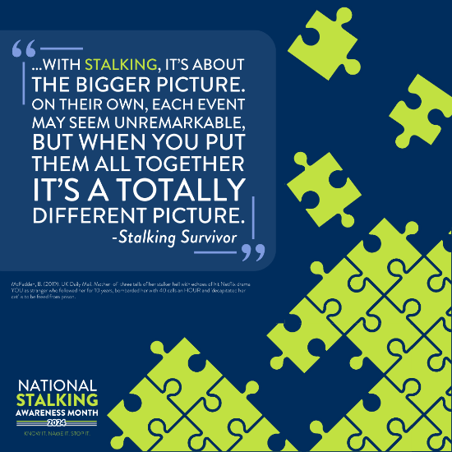 | Stalking is a pattern of behavior, also known as a “course of conduct.” While some incidents may seem trivial on their own, the cumulative effect can be terrifying. #KnowItNameItStopIt #NSAM2024
9 | Tues | 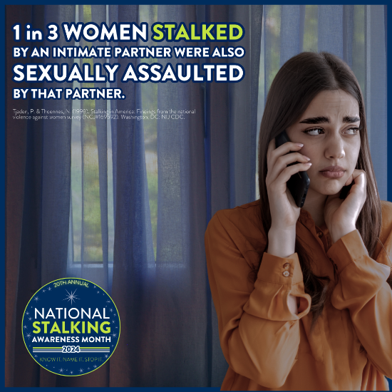 | Stalking often intersects with sexual violence. Some predators stalk while planning sexual violence, researching and/or grooming their victims. Other offenders stalk after committing sexual violence to intimidate their victims and/or extend the trauma of the assault. Ask sexual assault survivors about stalking victimization! #KnowItNameItStopIt #NSAM2024
10 | Wed | 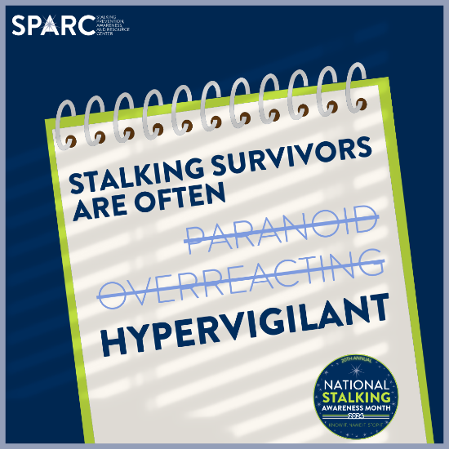 | Too often, stalking victims’ fears are minimized, trivialized, and/or dismissed entirely. When stalking victims change their daily lives to maximize their safety, they aren’t being paranoid – they’re being vigilant, and this vigilance has helped to keep them safe. #KnowItNameItStopIt #NSAM2024
11 | Thurs | 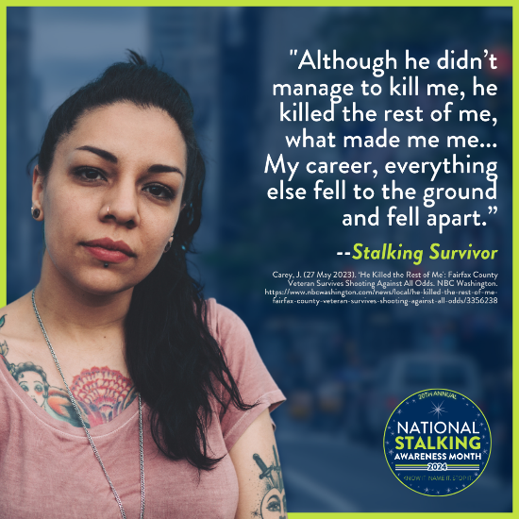 | Stalking is a traumatic victimization that can impact every part of a survivor’s life. Many survivors drastically change their lives to avoid the stalker’s surveillance, contact, intimidation, and/or sabotage. #KnowItNameItStopIt #NSAM2024
12 | Fri | 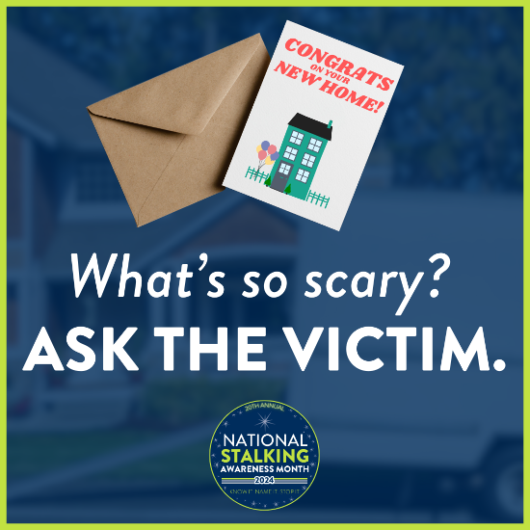 | Context is critical in understanding stalking. Receiving a congratulatory greeting card may be a welcome surprise for most of us – but when a stalking survivor has relocated to get away from an abusive partner and receives this at a confidential address, it can be a terrifying threat sending a clear message that the stalker has found the victim. #KnowItNameItStopIt #NSAM2024
13 | Sat | 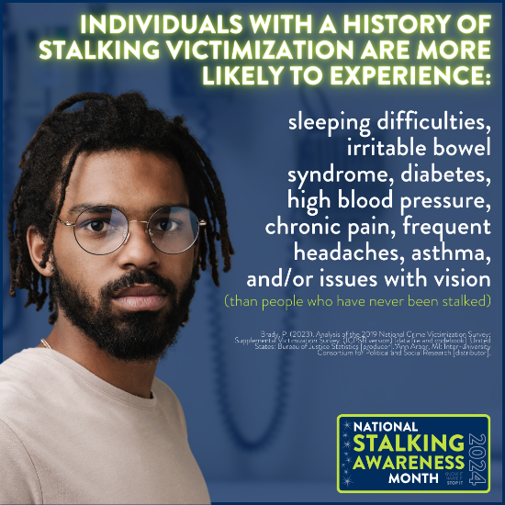 | Stalking is a health issue. In addition to these health outcomes, stalking is an indicator that victims may be experiencing intimate partner violence and/or sexual violence – with the same injuries and harms associated with those victimizations. #KnowItNameItStopIt #NSAM2024
14 | Sun | 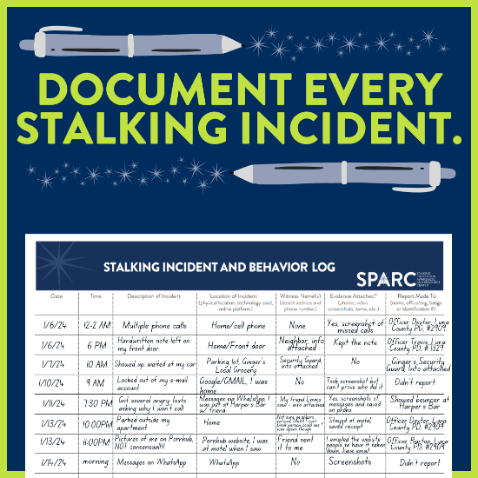  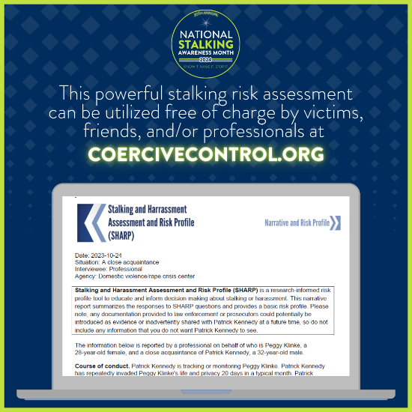 | Stalking incidents add up – but only if we do the math! The documentation log and SHARP assessment are practical tools to help victims best tell their stories, capture everything they’ve experienced, and assess risk. #KnowItNameItStopIt #NSAM2024
15 | Mon | 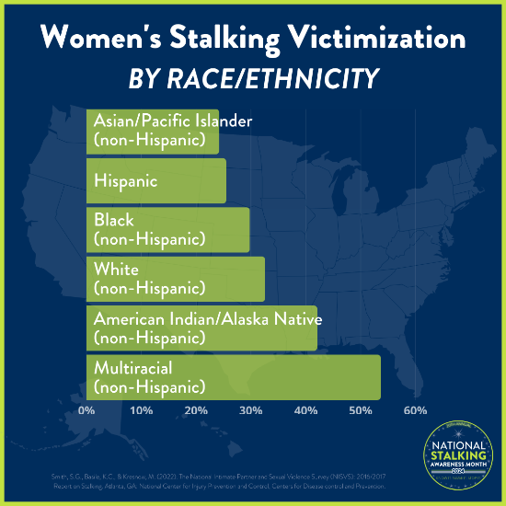  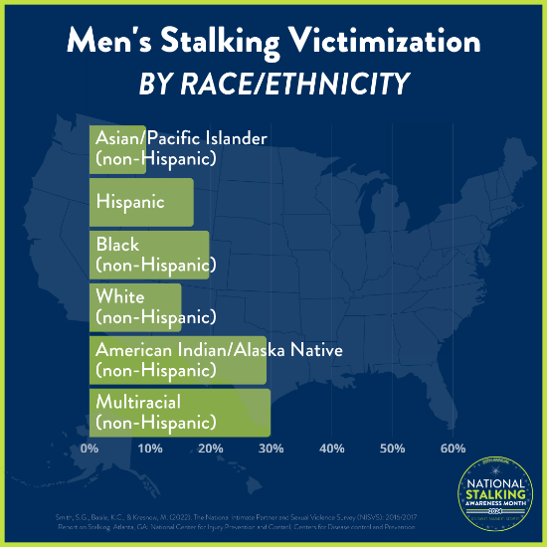 | Mixed race and Native American/Alaska Native women experience the highest rates of stalking victimization in the United States. Stalkers may target victims because of their perceived vulnerability and/or lack of credibility. #KnowItNameItStopIt #NSAM2024
16 | Tues | 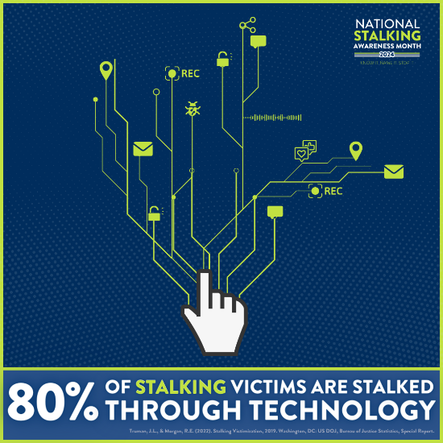 | Many victims are stalked both in-person and through technology. Technology-facilitated stalking can be just as invasive, threatening, and fear-inducing as in-person stalking. Victims of technology-facilitated stalking report being just as concerned for their safety as individuals who experience in-person stalking. #KnowItNameItStopIt #NSAM2024
17 | Wed | 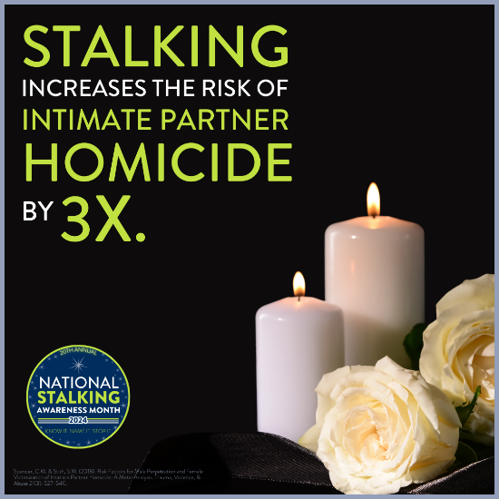 | Stalking is a significant risk factor for intimate partner homicide. Intimate partners who stalk are generally more dangerous than those who don’t stalk. Stalking must be taken seriously when it begins, not only when it escalates to violence. #KnowItNameItStopIt #NSAM2024
18 | Thurs | 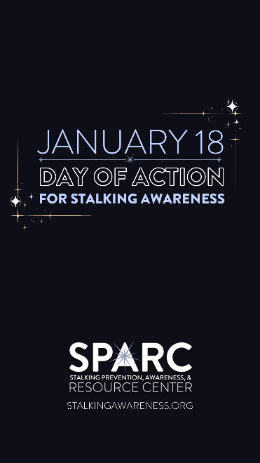  (Download this video here)  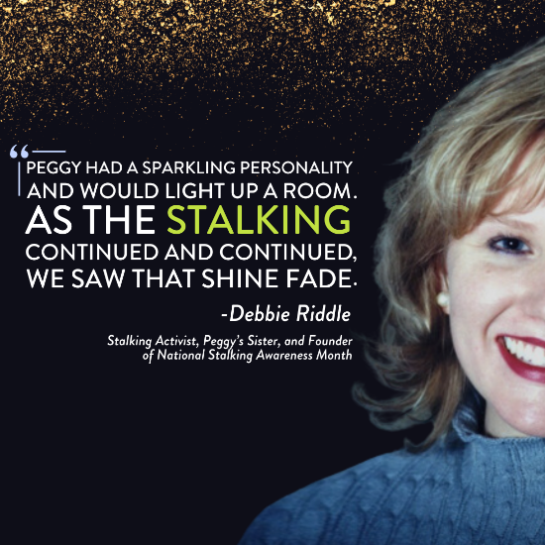  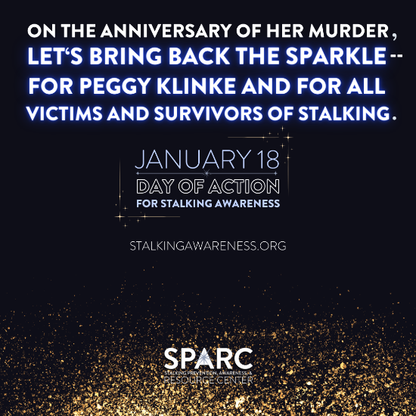  [Don’t forget to add your own sparkly photos to the post!] | Too often, the issue of stalking fades into the background. Not today. January 18th is the annual National Day of Action for Stalking Awareness, and we’re bringing back the sparkle – for Peggy Klinke and for all victims and survivors of stalking. Learn more at https://www.stalkingawareness.org/day-of-action-2024/ #SparkleAgainstStalking #NSAMDayofAction #KnowItNameItStopIt #NSAM2024
19 | Fri | 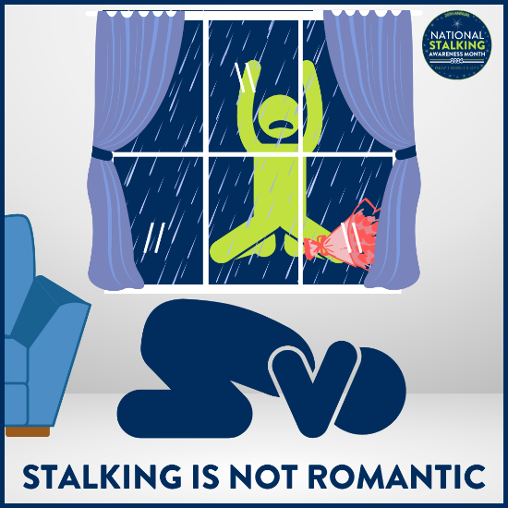 | Television, movies, and even friends and family may perpetuate the myth of stalking behaviors as flattering, cute, or romantic. This normalization can help to mask stalkers’ criminal behavior. In real life, there is nothing desirable about stalking. #KnowItNameItStopIt #NSAM2024
20 | Sat | 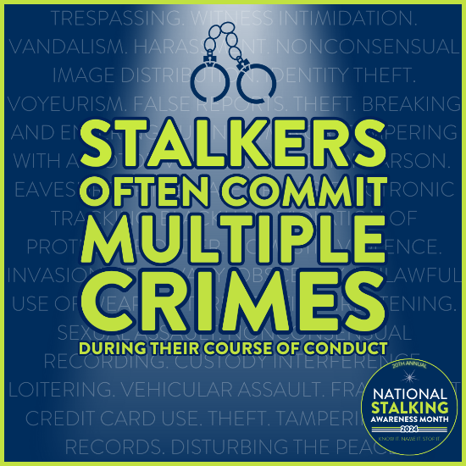 | Accountability matters! Many stalkers commit multiple crimes in their course of conduct. Report, document, and charge every relevant crime to best ensure offender accountability. #KnowItNameItStopIt #NSAM2024
21 | Sun | 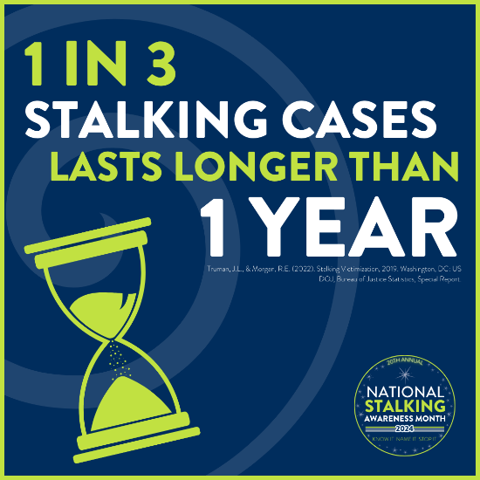 | Stalking cases are often dynamic and change over time, requiring ongoing risk assessment and safety planning. #KnowItNameItStopIt #NSAM2024
22 | Mon | 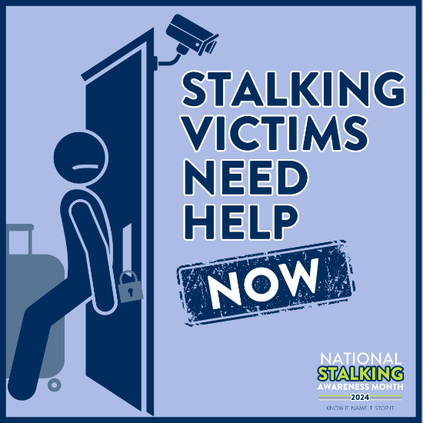 | Stalking often escalates over time. Don’t wait until violence or homicide to take stalking seriously. Many stalkers are violent, and stalking victims need help TODAY. #KnowItNameItStopIt #NSAM2024
23 | Tues | 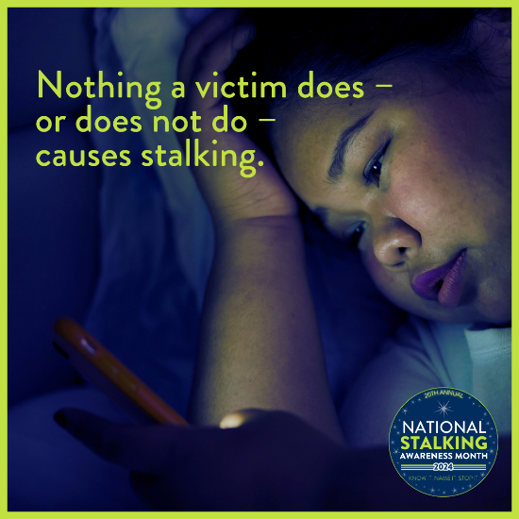 | While safety planning and risk reduction can be practical for victims, it’s critical to remember that only the stalker is responsible for his/her/their behavior. For example, the problem is NOT that victims share their locations on social media; rather, the problem is that stalkers exploit this information to terrorize their victims. #KnowItNameItStopIt #NSAM2024
24 | Wed | 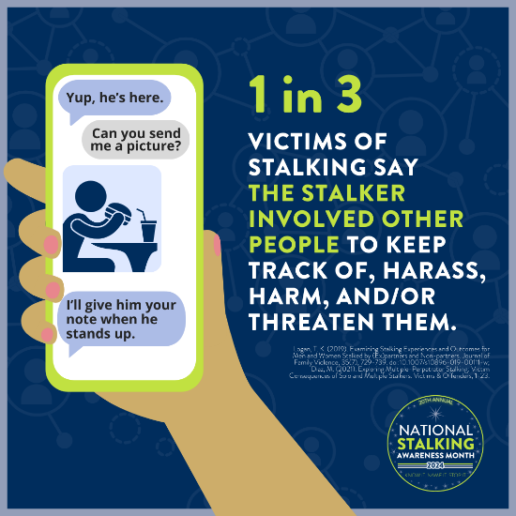 | "What time does his shift start?". "Did they end up getting that internship in the city?”. "Did she get home okay; can you see if the lights are on?”  Also known as proxy stalking, many offenders use third parties to extend their reach. Since the majority of stalking offenders know their victims, they may exploit shared social networks to gain information and access. Some of these third parties know they're helping a stalker -- and others may be tricked into it. #KnowItNameItStopIt #NSAM2024
25 | Thurs | 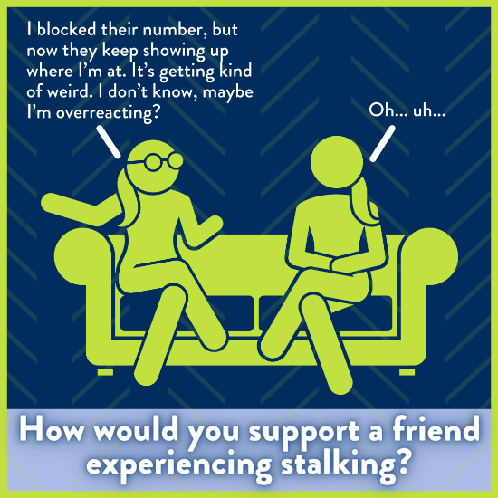 | Most stalking victims tell a friend or family member about the situation before seeking any formal help. Social supports can help mediate the negative effects of stalking. Learn more about how to support a friend at https://www.stalkingawareness.org/for-friends-loved-ones/ #KnowItNameItStopIt #NSAM2024
26 | Fri | 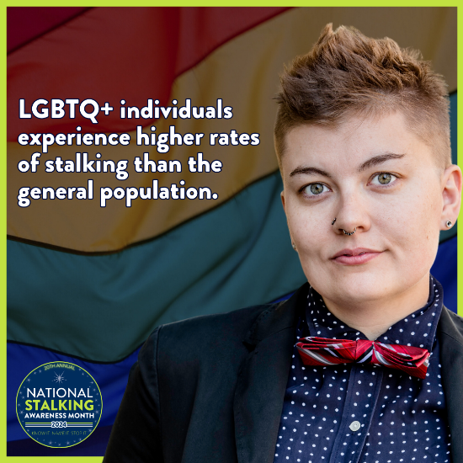 | Stalking can take on specific tactics and implications, especially when abusers identify characteristics that they can exploit as part of the abuse — including sexual orientation and gender identity. When stalkers target victims because of their sexual and/or gender identities, stalking may also be a hate crime. #KnowItNameItStopIt #NSAM2024
27 | Sat | 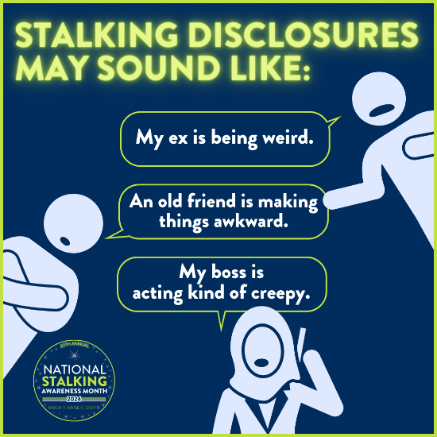 | Most victims of stalking don’t use the words “fear” or “stalking” – do you know what to listen for? #KnowItNameItStopIt #NSAM2024
28 | Sun | 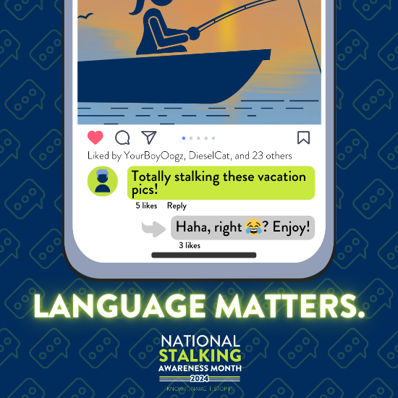 | The casual use of the word “stalking” doesn’t cause stalking - but it does trivialize the victimization. #KnowItNameItStopIt #NSAM2024
29 | Mon | 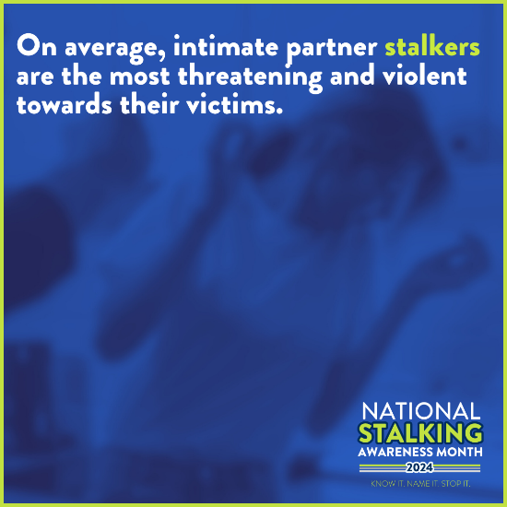 | All stalkers can be dangerous, but former or current intimate partners are generally more threatening, violent, and interfering than stalkers outside of an intimate relationship. Generally, the more access to and information about the victim that the stalker has, the more dangerous and threatening they can — and are likely to — be. #KnowItNameItStopIt #NSAM2024
30 | Tues | 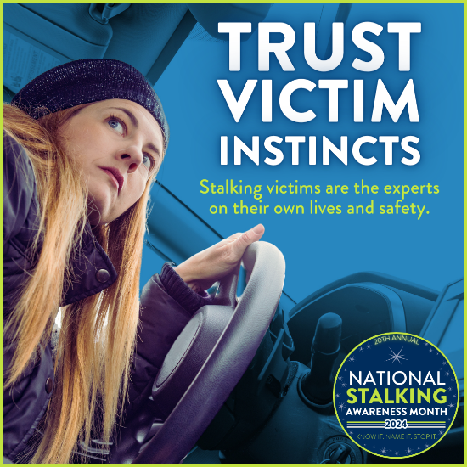 | Ask victims what they worry about and how they think the stalker will react to any changes they might make in their lives. Victims are often told to make their lives smaller to maximize safety – to leave the social media platform where stalking is happening or find a new gym, or to ignore the stalker’s behavior or tell them off. Often, these actions do not stop the stalking and can actually lead to stalkers escalating their behaviors. Stalkers are persistent and dangerous, and victims are the experts on their own lives and situations. #KnowItNameItStopIt #NSAM2024
31 | Wed | 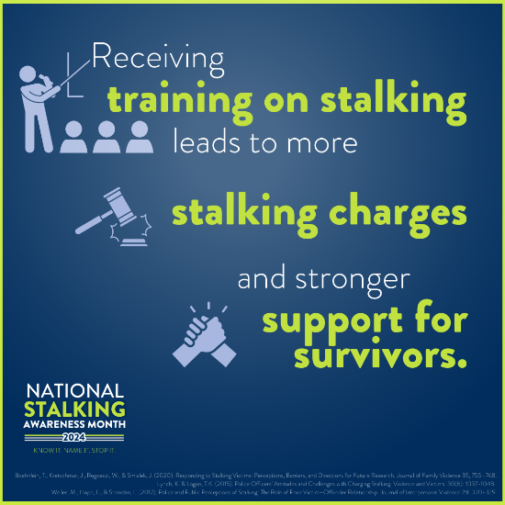 | Many professionals tasked with holding offenders accountable and/or helping keep victims safe have little training and few resources around recognizing and responding to stalking. SPARC is here to help! Check out our many recorded webinars, guides, and resources – and reach out to SPARC for training at http://www.stalkingawareness.org/request-a-training/. #KnowItNameItStopIt #NSAM2024
Feb 1 | Thurs | 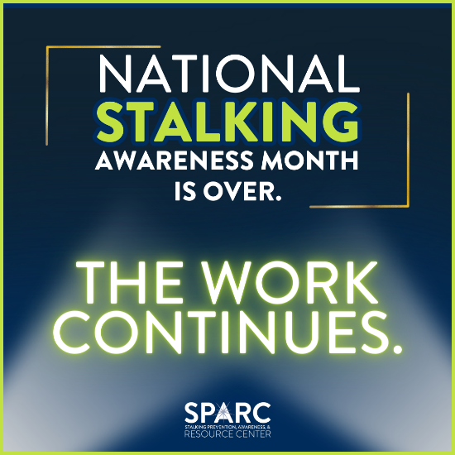 | Stalking Awareness Month may be over, but it’s always a good time for stalking awareness! Stalking affects every population and co-occurs with many other victimizations. Please use our resources to elevate the dialogue on stalking year-round! #KnowItNameItStopIt #NSAM2024

