NATIONAL STALKING AWARENESS MONTH
31 Days of Messaging: 2022

January 2022 marks the eighteenth annual National Stalking Awareness Month (NSAM), an annual call to action to recognize and respond to the serious crime of stalking. Use this toolkit to post to social media daily during January. Download graphics sized for Facebook, Instagram, and Twitter—as well as account banners, email signatures, and virtual meeting backgrounds—at www.stalkingawareness.org/stalking-awareness-month/.
January 2022 |  | Images | Text / Caption | Links
1 | Sat | 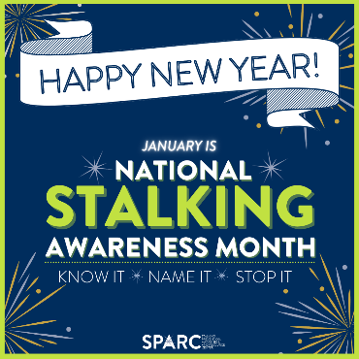 | This January marks the eighteenth annual National Stalking Awareness Month! #NSAM2022 Stalking is a serious and prevalent crime that deserves our attention. Join efforts this month and empower our communities to KNOW IT, NAME IT, and STOP IT. #KnowItNameItStopIt | NSAM 2022 landing page:  https://www.stalkingawareness.org/stalking-awareness-month/
2 | Sun | 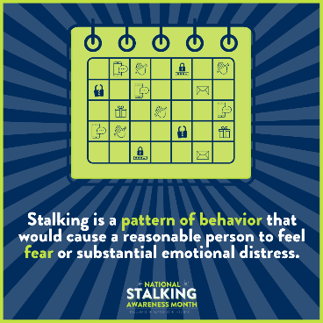 | Stalking isn’t just a “one off” event – it’s two or more behaviors directed at a specific person (or persons) that cause fear. Those behaviors can be in-person, through technology, or some combination. #NSAM2022 #KnowItNameItStopIt | “What is stalking” page: https://www.stalkingawareness.org/definition-faqs/#1537979509805-8a45c44f-4fcd
3 | Mon | 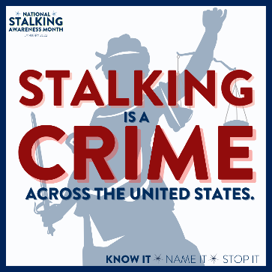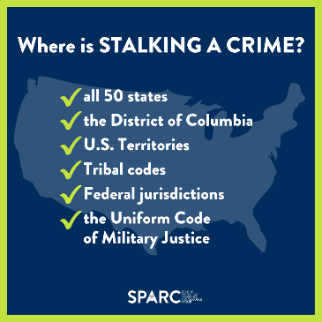 | Stalking survivors have the right to a criminal justice response! Too often, survivors and responders don’t realize that stalking is a crime in their jurisdictions. #NSAM2022 #KnowItNameItStopIt | “What is stalking”  video: https://www.stalkingawareness.org/definition-faqs/#1537979509805-8a45c44f-4fcd
4 | Tues | 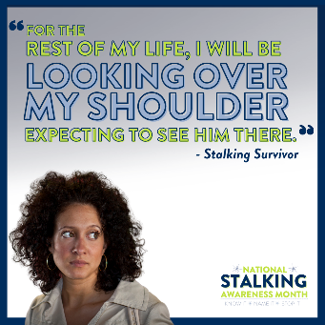  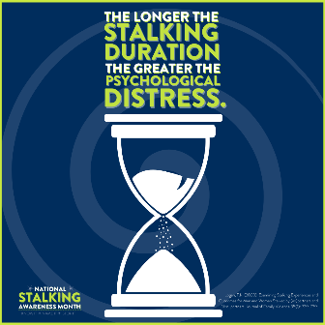 | Stalking isn’t just annoying or frustrating – it is traumatic. Many survivors experience depression, anxiety, PTSD, and other mental health impacts. Stalking victims are not paranoid or overreacting -- they are hypervigilant as a defense against the ongoing trauma they experience. #NSAM2022 #KnowItNameItStopIt
5 | Weds | 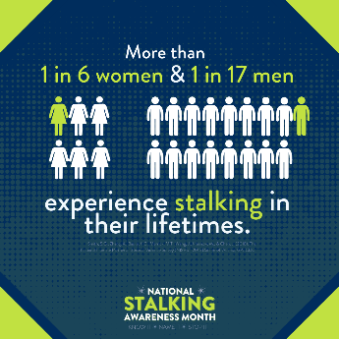 | Stalking is prevalent! Yet, stalking often goes unrecognized by the general public as well as within our criminal justice, civil justice, and victim services systems. #NSAM2022 #KnowItNameItStopIt | “Why learn about stalking” video: https://www.youtube.com/watch?v=JExXjGztlA8
6 | Thurs | 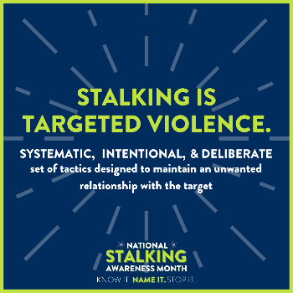 | Stalking is not an accident. Stalking is not a coincidence. Stalking is not a big misunderstanding. Stalking is targeted violence in which a perpetrator chooses to stalk. #NSAM2022 #KnowItNameItStopIt | “Stalking and violence” video: https://www.youtube.com/watch?v=2xZFN6x5QUk
7 | Fri | 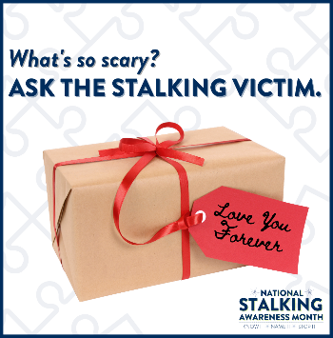 | Context is critical in stalking cases. What’s scary to a victim may not immediately be scary to you as an outsider. Share this video to spread the word! #NSAM2022 #KnowItNameItStopIt | “Context is key” video: https://www.youtube.com/watch?v=vfaYUuFQWuU&feature=emb_imp_woyt
8 | Sat | 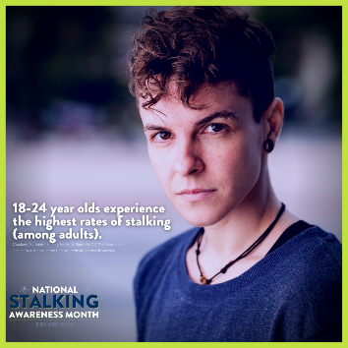 | Stalking impacts people of all ages, from children to older adults. Just as with dating violence and sexual violence, the rates are particularly high for young adults. #NSAM2022 #KnowItNameItStopIt
9 | Sun | 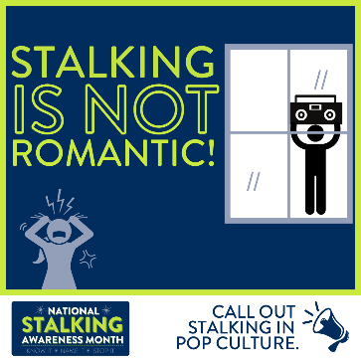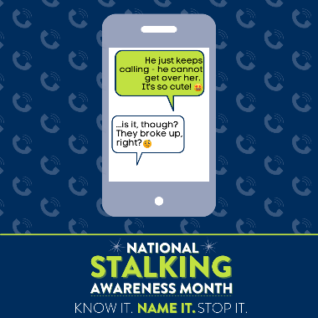 | Stalking is not romantic -- it is criminal, traumatic, and dangerous! Movies, TV, and music consistently present stalking as desirable, cute, sexy, and/or flattering – but in real life, it’s unwanted, terrifying, and illegal. Call out stalking when you see it in pop culture! #NSAM2022 #KnowItNameItStopIt | Media normalization of stalking materials:  https://www.stalkingawareness.org/awareness-educators/  and Spotify playlist: https://open.spotify.com/playlist/2EV9JMQCcef4guiteucK2X
10 | Mon | 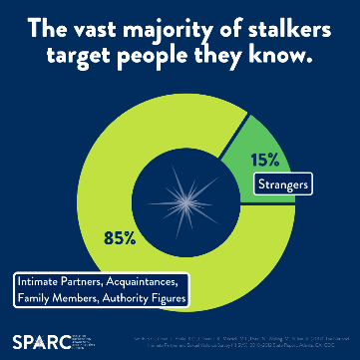 | When you envision a stalker, what image comes to mind? Our media shows many examples of shadowy strangers and/or obsessed fans. While this can happen, the majority of stalkers know their victims – and over half are current or former intimate partners. #NSAM2022 #KnowItNameItStopIt | IPV video 1:  https://youtu.be/WtmEYUpnVfk
11 | Tues | 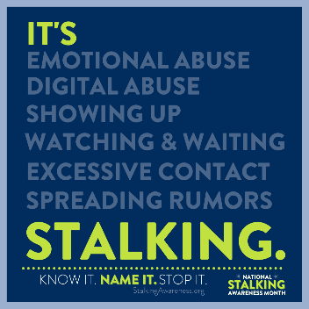 | How do you identify a stalking case? There are so many behaviors that can be part of a stalker’s pattern! While a stalker’s tactic(s) may or may not be criminal on their own (like texting), these behaviors can become criminalized as part of a stalking pattern of behavior. When abuse includes surveillance, life invasion, interference, and/or intimidation – that’s stalking. NAME IT! #NSAM2022 #KnowItNameItStopIt | “Stalking: name it” video:  https://www.youtube.com/watch?v=QbCiFy_kmyA
12 | Weds | 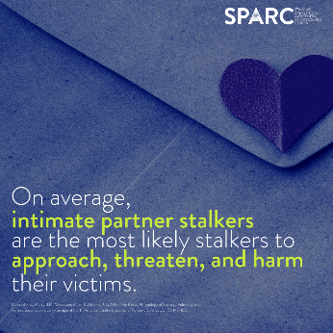 | All stalkers can be dangerous. On average, intimate partner stalkers pose the greatest threats to their victims. Stalking is a major red flag in a domestic violence relationship. Knowing the risk is critical! #NSAM2022 #KnowItNameItStopIt | IPV video 2:  https://www.youtube.com/watch?v=SR9SRqsvzYA
13 | Thurs | 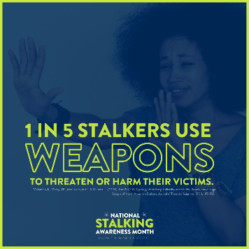 | Stalking is dangerous. Many stalkers use weapons to intimidate or directly harm their victims. #NSAM2022 #KnowItNameItStopIt | Safety planning guide:  https://www.stalkingawareness.org/wp-content/uploads/2018/11/Safety-Strategies.pdf
14 | Fri | 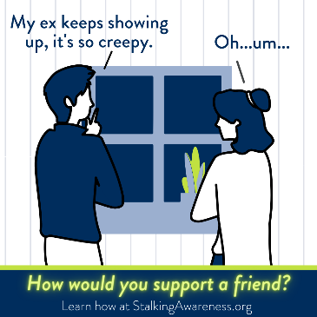 | Most victims of stalking share their concerns with a friend, family member, or someone else they trust before pursuing any sort of professional or legal help. If a stalking victim talks to you, your response makes a huge difference in if they feel validated and/or continue to seek help! Learn how to support a loved on experiencing stalking at (https://www.stalkingawareness.org/for-friends-loved-ones/). #NSAM2022 #KnowItNameItStopIt | “Supporting friends and loved ones” video: https://www.youtube.com/watch?v=an5m3ScZI8k&feature=emb_imp_woyt  and/or page: https://www.stalkingawareness.org/for-friends-loved-ones/
15 | Sat | 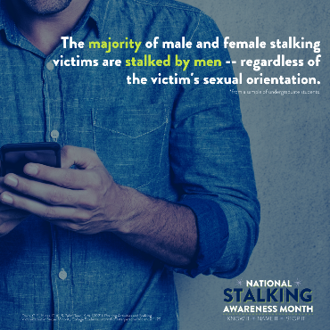 | Over 80% of the time, female victims report that their stalker is male. In over 50% of cases, male victims say the same. Men stalk other men in a wide variety of contexts. Sometimes, men are primarily stalking a previous female partner and begin stalking their ex-partners’ new romantic interests. #NSAM2022 #KnowItNameItStopIt
16 | Sun | 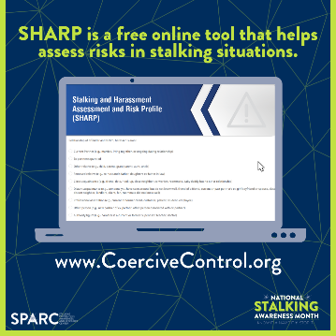 | Spread the word! There’s a risk assessment specifically for the crime of stalking. It’s easy-to-use, free of cost, and online. Completing this assessment can be helpful for victims, their support systems, as well as responders. #NSAM2022 #KnowItNameItStopIt | SHARP: https://www.stalkingawareness.org/sharp/
17 | Mon (off) | 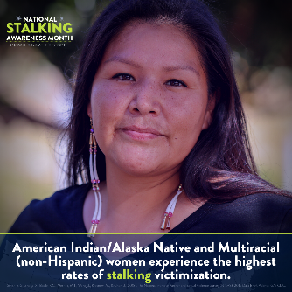  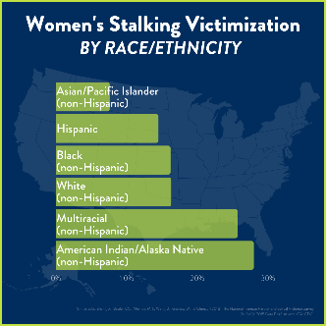 | Stalking impacts diverse populations across the gender, age, race, ethnicity, religious, and socioeconomic spectrums. American Indian/Alaska Native and multiracial women experience the highest rates of stalking. #NSAM2022 #KnowItNameItStopIt
18 | Tues | 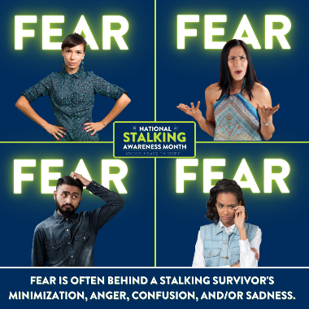 | Different people respond to trauma differently, and many people are not comfortable saying “I am feeling fear/afraid.” Victims may present as frustrated, angry, confused, sad, or show no affect at all – but fear is likely behind these responses. Teaching others to understand this helps to support victims reporting and improve response services. #NSAM2022 #KnowItNameItStopIt
19 | Weds | 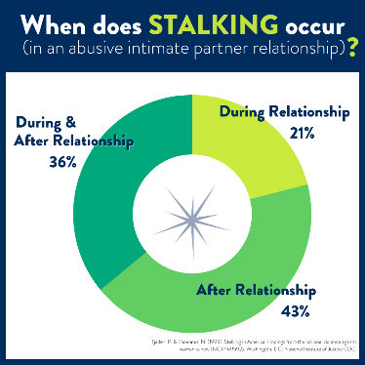 | If a partner is showing up, following, contacting constantly, violating privacy, sabotaging, or otherwise scaring the victim – that’s stalking! It can happen before, during, and/or after a relationship. Over half the time, stalking takes places during the relationship and can be a red flag that the relationship might be particularly dangerous. #NSAM2022 #KnowItNameItStopIt | IPV factsheet:  https://www.stalkingawareness.org/wp-content/uploads/2018/11/Stalking-IPV-Fact-Sheet.pdf
20 | Thurs | 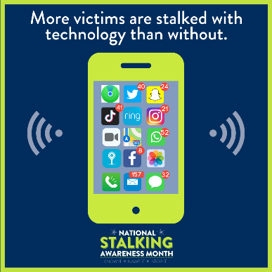 | The majority of stalking victims experience both in-person and technology-facilitated stalking. The most common types of tech abuse—harassment, limiting access to technology, and surveillance—increased during the pandemic. NNEDV’s Safety Net app has helpful information to help victims take control of their online privacy. #NSAM2022 #KnowItNameItStopIt | NNEDV Safety Net:  https://www.techsafety.org/safetynetapps
21 | Fri | 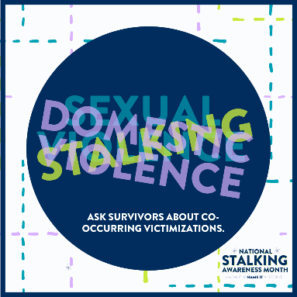 | So often, stalking, domestic violence, and/or sexual violence are overlapping victimizations – but some may be more immediately apparent than others. Ask domestic violence, sexual assault, and stalking victims about the full extent of their experiences to enhance their safety and hold offenders accountable. #NSAM2022 #KnowItNameItStopIt
22 | Sat | 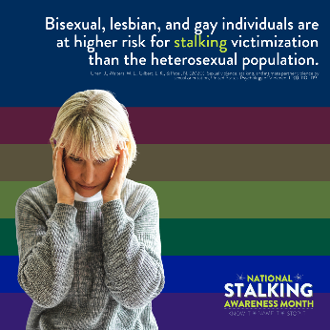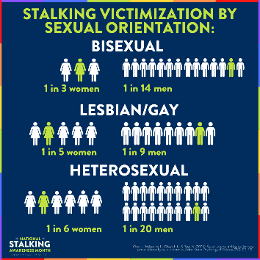 | People of all gender identities and sexual orientations experience stalking. Generally, research shows that LGBTQ+  individuals are more likely than heterosexual and cisgender individuals to experience stalking. #NSAM2022 #KnowItNameItStopIt | Stalking and LGBTQ factsheet: https://www.stalkingawareness.org/wp-content/uploads/2021/09/SPARC_Stalking-LGBTQ-Fact-Sheet.pdf
23 | Sun | 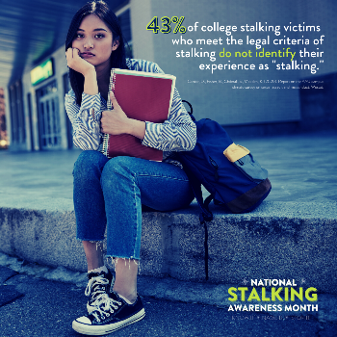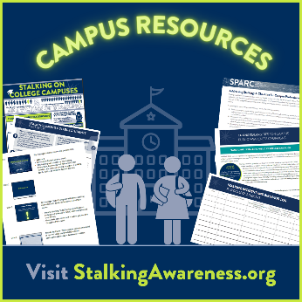 | Helping victims identify stalking helps increase reporting and help-seeking! #NSAM2022 #KnowItNameItStopIt | “Campus stalking” video: https://www.youtube.com/watch?v=EVXFZmLpPzg&feature=emb_imp_woyt  and campus resources: https://www.stalkingawareness.org/campus-resources/
24 | Mon | 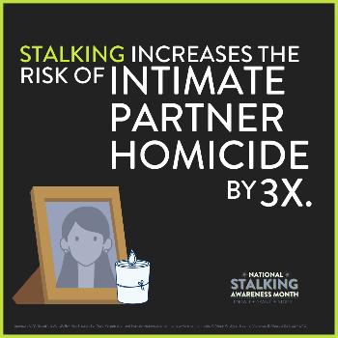 | Intimate partner stalking is a significant risk factor for intimate partner homicide. Too often, stalking is only recognized after violence or murder – even despite victims’ reports. We must identify stalking behaviors and act with urgency to keep victims safe. #NSAM2022 #KnowItNameItStopIt | IPV infographic:  https://www.stalkingawareness.org/wp-content/uploads/2019/10/Stalking__DV_Infographic.pdf
25 | Tues | 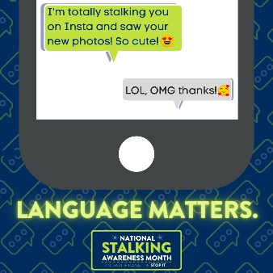 | The casual use of the word "stalking" can make it harder for victims and responders to identify this dangerous crime. #NSAM2022 #KnowItNameItStopIt
26 | Wed | 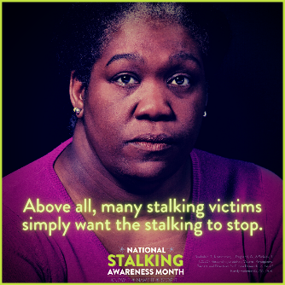 | It’s important to ask stalking victims what a successful resolution of the situation would look like to them. It may or may not include the criminal justice system. #NSAM2022 #KnowItNameItStopIt
27 | Thur | 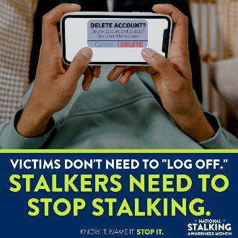 | When survivors can’t access (or have limited access to) technology, it’s harder to keep in touch with friends and family as well as access victim services, legal support, courts, and other services and social supports. #NSAM2022 #KnowItNameItStopIt
28 | Fri | 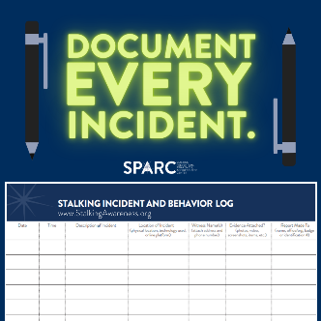 | Stalking incidents add up – but only if we do the math. Victims are encouraged to document all of the stalking behaviors that they experience. SPARC’s documentation log can help. #NSAM2022 #KnowItNameItStopIt | Documentation log:  https://www.stalkingawareness.org/wp-content/uploads/2018/07/SPARC_StalkingLogInstructions_2018_FINAL.pdf
29 | Sat | 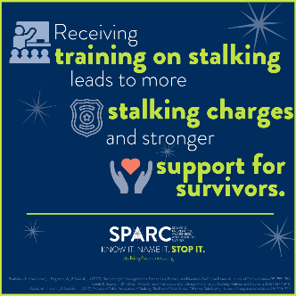  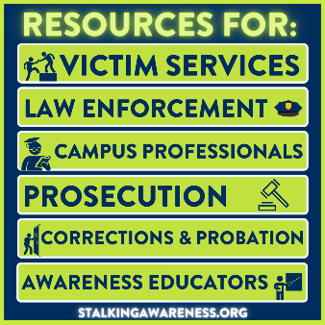 | Many professionals tasked with supporting survivors and/or holding stalkers accountable have little or no training on stalking. The good news is that SPARC has many resources to help – check out recorded webinars, guides for different professionals, and/or request a SPARC training for your team. #NSAM2022 #KnowItNameItStopIt | Training request page:  https://www.stalkingawareness.org/request-a-training/  and recorded trainings: https://www.stalkingawareness.org/training-archive/
30 | Sun | 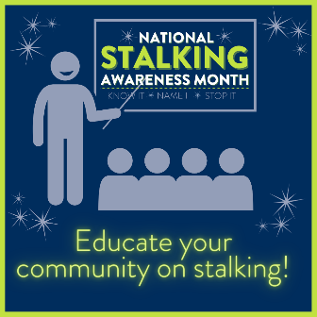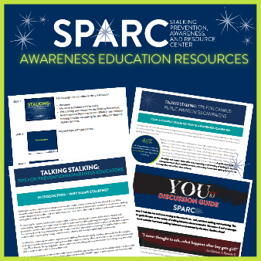  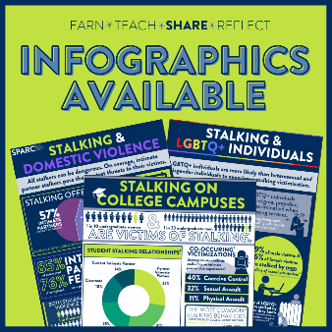  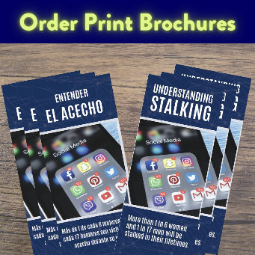 | Do you offer awareness trainings on topics like sexual and dating violence? If so, make sure you’re also talking about stalking! Public misperceptions about stalking can be dangerous. SPARC’s free workshops, discussion guides, infographics, brochures, and tips for educators can help you spread awareness in your community. #NSAM2022 #KnowItNameItStopIt | Awareness page: https://www.stalkingawareness.org/awareness-educators/  and videos: https://www.stalkingawareness.org/videos/
31 | Mon | 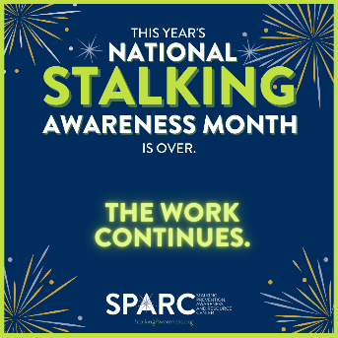 | THANK YOU for making #NSAM2022 a success! While January is ending, the need to recognize the urgency of stalking – and KNOW IT, NAME IT, and STOP IT -- is critical year-round. #KnowItNameItStopIt | General webpage: www.stalkingawareness.org
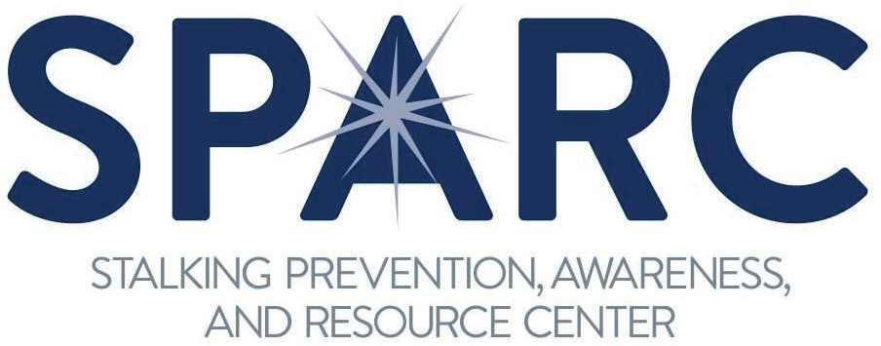
This project was supported by Grant No. 2017-TA-AX-K074 awarded by the Office on Violence Against Women, U.S. Department of Justice. The opinions, findings, conclusions, and recommendations expressed in this publication/program/exhibition are those of the author(s) and do not necessarily reflect the views of the Department of Justice, Office on Violence Against Women.
1000 Vermont Avenue NW, Suite 1010 | Washington, DC 20005 | (202) 558-0040 | stalkingawareness.org
@FollowUsLegally

