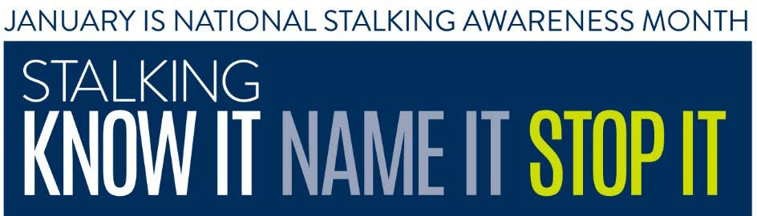

National Stalking Awareness Month Proclamation
January 2020
Whereas, under the laws of all fifty states, the U.S. Territories, the District of Columbia, and federal government, stalking is a crime;
Whereas, 6- 7.5 million people are stalked in a one-year period in the United States, and the majority of victims are stalked by someone they know;
Whereas, 3 in 4 women killed by an intimate partner have been stalked by that intimate partner;
Whereas, many stalking victims lose time from work and experience serious psychological distress and lost productivity at a much higher rate than the general population;
Whereas, many stalking victims are forced to protect themselves by relocating, changing their identities, changing jobs, and obtaining protection orders;
Whereas, many stalkers use technology—such as cell phones, global positioning systems (GPS), cameras, and spyware— to monitor and track their victims;
Whereas, there is a need for great public awareness about the nature, criminality, and potential lethality of stalking;
Whereas, criminal justice systems can enhance their responses to stalking by regular training and assertive investigation and prosecution of the crime;
Whereas, laws and public policies must be continually adapted to keep pace with new tactics used by stalkers;
Whereas, communities can better combat stalking by adopting multidisciplinary responses by teams of local agencies and organizations and by providing more and better victim services;
and Whereas, NAME OF ORGANIZATION is joining forces with victim service providers, criminal justice officials, and concerned citizens throughout LOCATION and the United States to observe National Stalking Awareness Month.
NOW, THEREFORE, I, NAME, as GOVERNOR/MAYOR/OTHER TITLE of
LOCATION, do hereby proclaim January 2020 as STALKING AWARENESS MONTH in LOCATION and applaud the efforts of the many victim service providers, police officers, prosecutors, national and community organizations, and private sector supporters for their efforts in promoting awareness about stalking.

SIGNATURE

DATE

