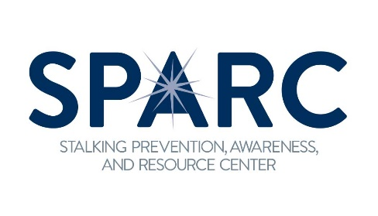
TRAINING REQUEST FORM
Contact Information
Organization:Click or tap here to enter text.
Agency Contact Name:Click or tap here to enter text.
Address:Click or tap here to enter text.
City, State, Zip: Click or tap here to enter text.
Phone:Click or tap here to enter text.
Email & Website:Click or tap here to enter text.
Legal name and federal ID number of host agency:Click or tap here to enter text.
Billing contact information (Name, Title, Email): Click or tap here to enter text.
Signatory (Name, Title, Email): Click or tap here to enter text.
Do OVW grant funds support your agency or event? Choose an item.
If yes, please list grant name:Choose an item.
Event Information
Event Title:Click or tap here to enter text.
Date and time of event:Click or tap here to enter text.
Is your date flexible: Choose an item.
Purpose/Goals of Event:Click or tap here to enter text.
Audience disciplines, experience level:Click or tap here to enter text.
Estimated number of attendees: Click or tap here to enter text.
Is the event local, regional, state, or national in scope? Choose an item.
De we have permission to announce our involvement on our website? Choose an item.
If yes, please include relevant links: Click or tap here to enter text.
Presentation topics and training content requested: Click or tap here to enter text.
Will attendees be asked to evaluate the presentation? Choose an item.
If yes, will you provide the evaluation to SPARC?Choose an item.
Will you be able to provide SPARC with contact information, including email addresses for attendees? Choose an item.
Please specify which of our travel associated costs you can cover (typical costs include air travel, hotel, per diem, and ground transportation): Click or tap here to enter text.
Any other information you would like to provide: Click or tap here to enter text.
Please email the completed form to jlandhuis@aequitasresource.org

