31 DAYS OF MESSAGING TOOLKIT
NATIONAL STALKING AWARENESS MONTH
31 Days of Messaging: 2023

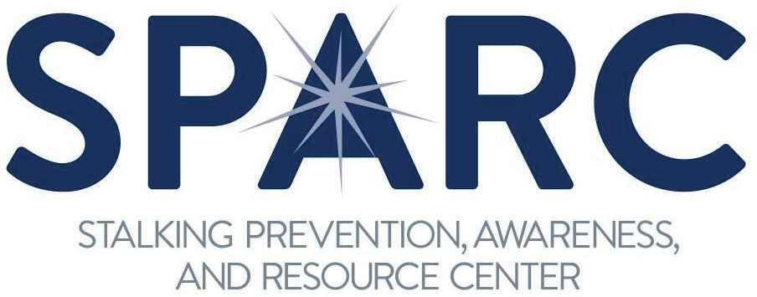
January 2023 marks the nineteenth annual National Stalking Awareness Month (NSAM), an annual call to action to recognize and respond to the serious crime of stalking. Use this toolkit to post to social media daily during January. Download graphics sized for Facebook, Instagram, and Twitter—as well as account banners, email signatures, and virtual meeting backgrounds—at www.stalkingawareness.org/stalking-awareness-month-2023/. Stalking awareness is always important, so follow us on social media @FollowUsLegally and share our posts year-round!
This project was supported by Grant No. 2017-TA-AX-K074 awarded by the Office on Violence Against Women, U.S. Department of Justice. The opinions, findings, conclusions, and recommendations expressed in this publication/program/exhibition are those of the author(s) and do not necessarily reflect the views of the Department of Justice, Office on Violence Against Women.
1000 Vermont Avenue NW, Suite 1010 | Washington, DC 20005 | (202) 558-0040 | stalkingawareness.org
@FollowUsLegally
January 2023 |  | Images | Text / Caption | Links
1 | Sun | 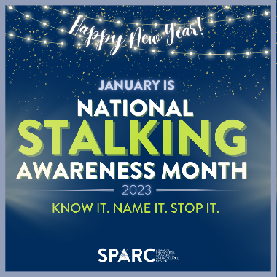 | Happy New Year! It’s January 2023, the nineteenth annual National Stalking Awareness Month. Stalking is a serious and prevalent victimization that deserves our attention year-round. Please join our efforts and amplify our call to KNOW IT, NAME IT, and STOP IT!  Resources available at https://www.stalkingawareness.org/stalking-awareness-month-2023/ #KnowItNameItStopIt #NSAM2023 | https://www.stalkingawareness.org/stalking-awareness-month-2023/
2 | Mon | 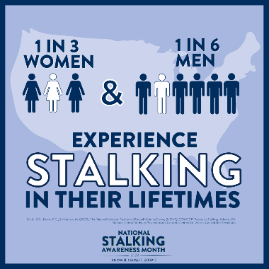 | Stalking is a prevalent victimization across the United States with numbers that rival rates of intimate partner and sexual violence. Stalking is its own form of violence with its own risks, support and safety planning needs, and legal responses. #NSAM2023 #KnowItNameItStopIt

3 | Tues | 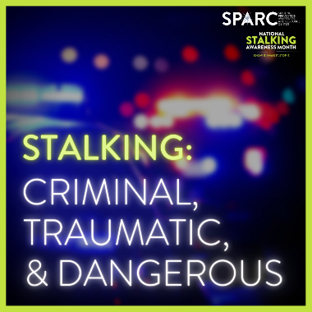 | Too often -- despite its high prevalence and serious impacts – stalking goes unrecognized and is not responded to with the urgency needed. That’s why we must know it, name it, and stop it! #NSAM2023 #KnowItNameItStopIt | Watch a quick video to learn more: https://www.youtube.com/watch?v=-V29aj-J874
4 | Weds | 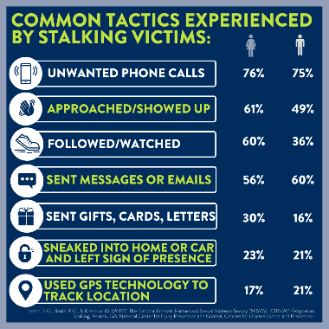 | Many stalkers are persistent offenders who utilize a wide range of tactics to contact, surveil, control, isolate, sabotage, and otherwise scare their victims. #NSAM2023 #KnowItNameItStopIt
5 | Thurs | 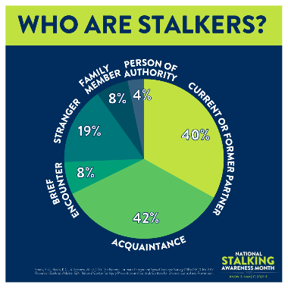 | In popular culture, stalkers are often portrayed as shadowy strangers or mysterious secret admirers. In reality, the vast majority of offenders know their victims and are primarily intimate partners or acquaintances. #NSAM2023 #KnowItNameItStopIt
6 | Fri | 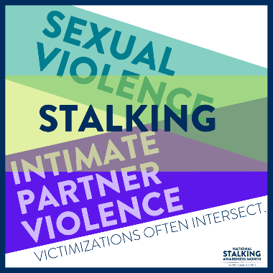 | ASK ABOUT CO-OCCURING VICTIMIZATIONS! Stalking requires its own safety planning and responses. Additionally, victims of stalking are often at increased risk for other forms of violence. NAME IT. #NSAM2023 #KnowItNameItStopIt | Watch a quick video or two to learn more: https://www.youtube.com/watch?v=EVuvlpsYhuI  https://www.youtube.com/watch?v=WtmEYUpnVfk
7 | Sat | 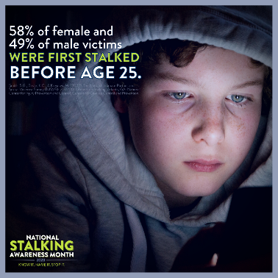 | Stalking impacts people of all ages, from children to older adults. Many survivors are first stalked as teens or young adults. #NSAM2023 #KnowItNameItStopIt
8 | Sun | 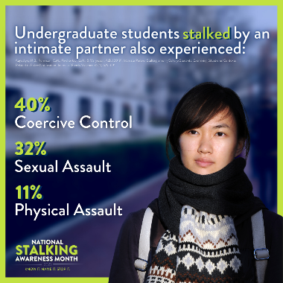 | Stalking is covered under Title IX and the Clery Act and merits the same level of campus awareness and response directed at sexual assault and intimate partner violence. Many students experience multiple victimizations. #NSAM2023 #KnowItNameItStopIt
9 | Mon | 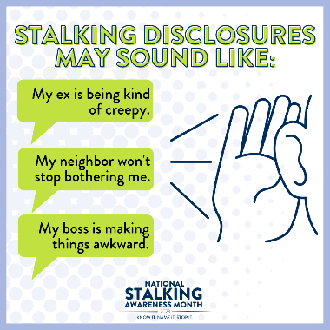 | Most victims of stalking don’t use the words “fear” or “stalking” – do you know what to listen for? #NSAM2023 #KnowItNameItStopIt
10 | Tues | 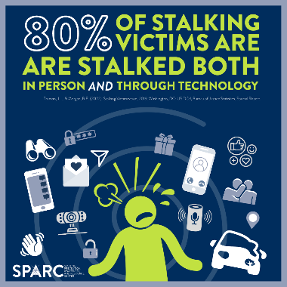 | Stalkers are inventive offenders who use (and misuse) technologies in a variety of creative ways to scare their victims. Victims of technology-facilitated stalking report being just as concerned for their safety as individuals who experience in-person stalking. #NSAM2023 #KnowItNameItStopIt
11 | Weds | 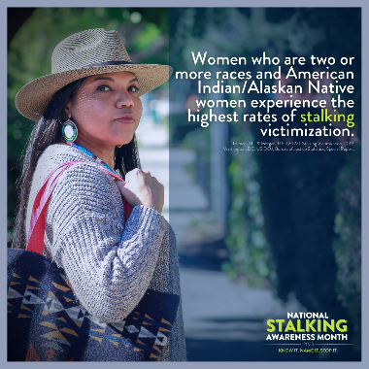 | Women, young adults, individuals with disabilities, multiracial individuals, and people of color generally experience stalking at higher rates. Individuals with more than one of these identities may be even more likely to experience stalking. As with many types of interpersonal violence, abusers often target stalking victims because of characteristics that make them less likely to report the violence and less likely to be believed or taken seriously if they do report it. #NSAM2023 #KnowItNameItStopIt
12 | Thurs | 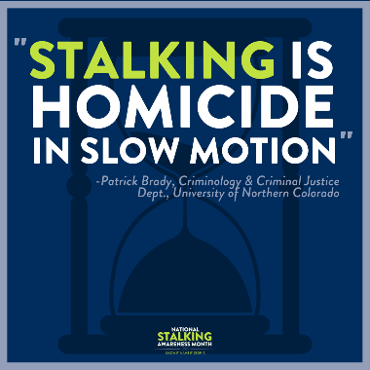 | Too often, stalking behaviors are only taken seriously after a victim has been harmed or killed. Many stalkers are violent, and stalking victims need help NOW -- not in retrospect. #NSAM2023 #KnowItNameItStopIt
13 | Fri |  | Context is critical in understanding stalking. A post-it note that says “miss you” is not universally scary – but when a stalking survivor has relocated to get away from an abusive partner, starts a new job, and sees this note at their desk in their ex’s handwriting, it can be a terrifying threat sending a clear message that the stalker has found them and plans to continue their abuse. #NSAM2023 #KnowItNameItStopIt | Watch a quick video to learn more: https://www.youtube.com/watch?v=-V29aj-J874
14 | Sat |  | While all stalkers can be dangerous, intimate partner stalkers – who often have the most access and information about their victims – are, on average, the most threatening and violent. #NSAM2023 #KnowItNameItStopIt | Watch a quick video to learn more: https://www.youtube.com/watch?v=SR9SRqsvzYA
15 | Sun | 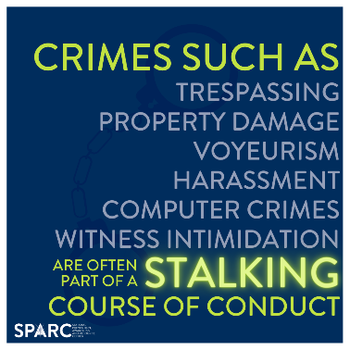 | Stalkers must be held accountable! Many offenders commit multiple crimes in their course of conduct. It is critical to report, document, and charge every relevant crime to best ensure offender accountability. Additionally, depending on your jurisdiction’s statute, these compounding crimes can be aggravating factors that increase the penalties in stalking cases. #NSAM2023 #KnowItNameItStopIt
16 | Mon (off) | 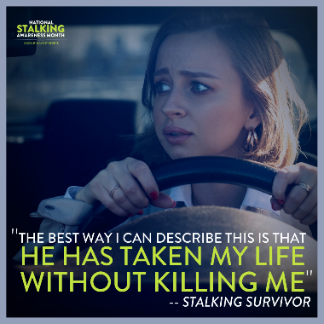 | Stalking is a traumatic victimization that can impact every part of a survivor’s life. Many survivors drastically change their lives to avoid the stalker’s surveillance, contact, intimidation, and/or sabotage. #NSAM2023 #KnowItNameItStopIt
17 | Tues | 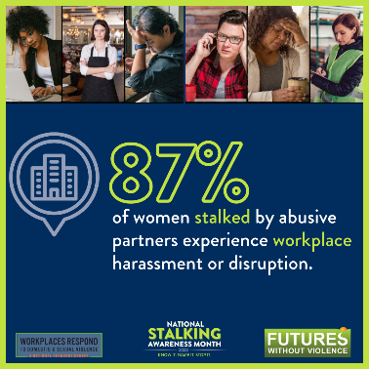  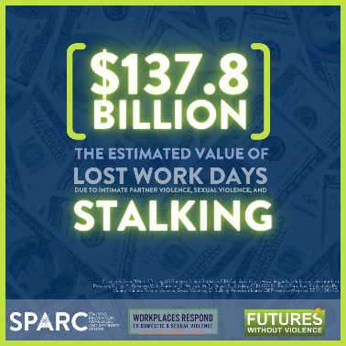  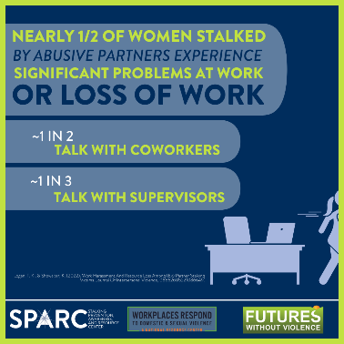 | Stalking can be a costly victimization in every way. Stalkers often target their victims at work, jeopardizing victim livelihoods and safety as well as broader workplace security. Many victims have their employment significantly disrupted and even lose their jobs as a result of the stalking victimization. Due to misperceptions and difficult to navigate reporting processes, many stalking victims feel unable to discuss the situation with their colleagues or supervisors.  Putting in place responsive policies, sick and safe leave, and other protective measures for survivors of intimate partner violence, sexual violence, and stalking can help workplaces keep employees safe. Learn more at workplacesrespond.org. #NSAM2023 #KnowItNameItStopIt | Learn more at https://www.workplacesrespond.org/  Twitter: @WithoutViolence  Instagram: @futureswithoutviolence  Facebook: FuturesWithoutViolence
18 | Weds | 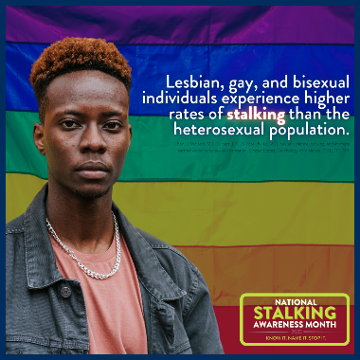 | Stalking can take on specific tactics — and implications — when abusers identify characteristics that they can exploit as part of the abuse, including sexual orientation and gender identity. #NSAM2023 #KnowItNameItStopIt
19 | Thurs | 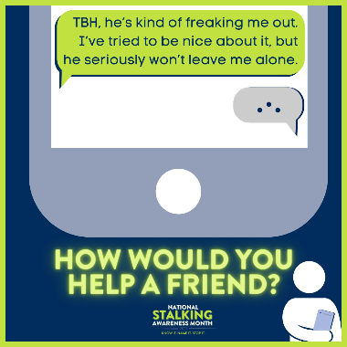 | Most stalking victims tell a friend or family member first, and that trusted person’s response can have a significant impact on whether or not the victim seeks help from professionals.  #NSAM2023 #KnowItNameItStopIt | Learn more about responding to friends at https://www.youtube.com/watch?v=2pkJI7FOvTE
20 | Fri | 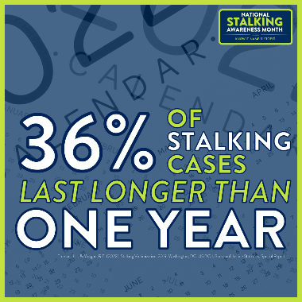 | A stalking course of conduct can span an afternoon or a lifetime. Stalking cases are often dynamic and change over time, requiring ongoing risk assessment and safety planning. #NSAM2023 #KnowItNameItStopIt
21 | Sat | 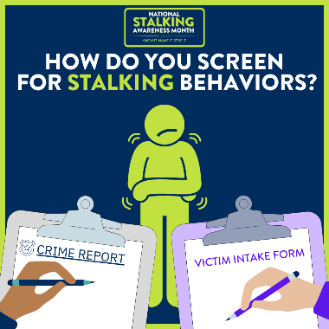  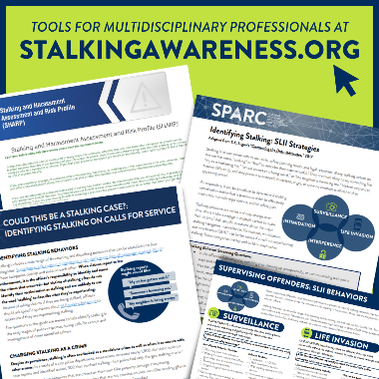 | Most stalking victims don’t use the word “stalking” when describing their experiences, so it’s up to responders to ask the right questions to best identify stalking behaviors. SPARC’s tools for victim service providers, law enforcement, corrections, prosecution, and other disciplines can help responders better screen for stalking behaviors. #NSAM2023 #KnowItNameItStopIt
22 | Sun | 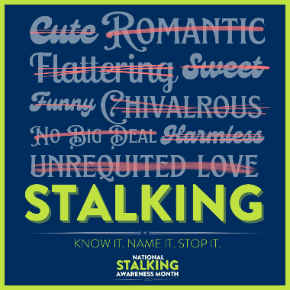 | There is nothing romantic, cute, flattering, or otherwise desirable about stalking. #NSAM2023 #KnowItNameItStopIt
23 | Mon | 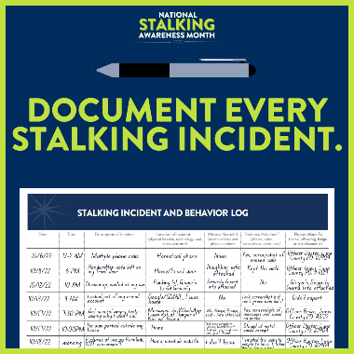  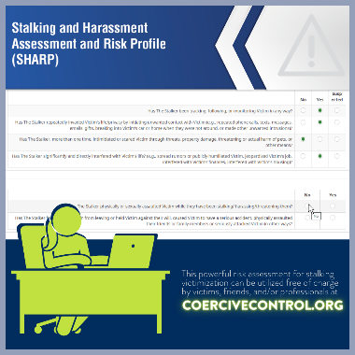 | Stalking incidents add up -- but only when we do the math. Tools like documentation logs (available at (https://www.stalkingawareness.org/documentation-log/) and the SHARP assessment (at www.StalkingRisk.com) can help victims succinctly describe their cases for easier coordination. #NSAM2023 #KnowItNameItStopIt | Documentation logs are available at https://www.stalkingawareness.org/documentation-log/ and the SHARP assessment is available at www.StalkingRisk.com.
24 | Tues | 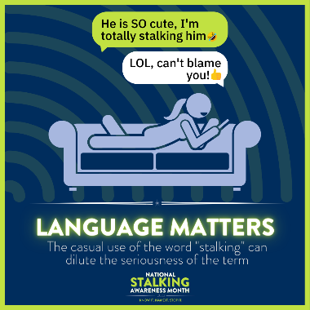 | While the casual use of the word “stalking” is not the cause of stalking behavior, it can dilute the seriousness of the term and create a false sense that stalking is a trivial matter. In reality, it is anything but. #NSAM2023 #KnowItNameItStopIt
25 | Wed | 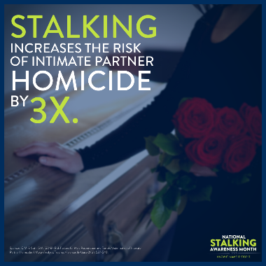 | Stalking is one of the top risk factors for intimate partner homicide. #NSAM2023 #KnowItNameItStopIt
26 | Thur | 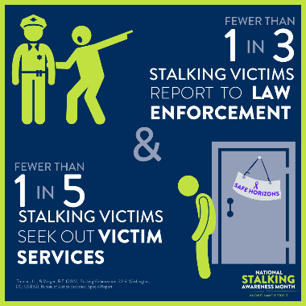 | How do your services reach stalking victims? Many stalking victims do not know where to turn for help. #NSAM2023 #KnowItNameItStopIt
27 | Fri | 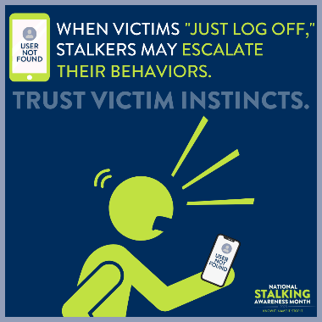 | When victims create distance from their stalkers – for example, by blocking them on social media or changing their phone numbers – offenders may actually escalate their behaviors. Ask victims how they think the offender will react. #NSAM2023 #KnowItNameItStopIt
28 | Sat | 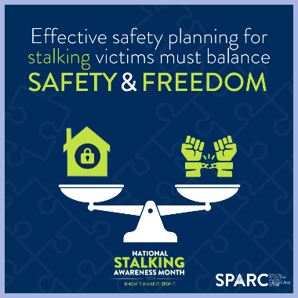 | Victims are often told to make their lives smaller to maximize safety. Different victims are willing (and unwilling) to make different compromises. Respect and plan around the victim’s priorities. #NSAM2023 #KnowItNameItStopIt
29 | Sun | 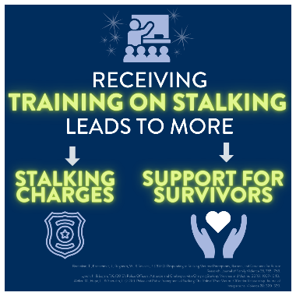 | Many of the professionals tasked with holding offenders accountable and/or keeping victims safe have little training around recognizing and responding to stalking. Reach out to SPARC for training at http://www.stalkingawareness.org/request-a-training/! #NSAM2023 #KnowItNameItStopIt | Reach out to SPARC for training at http://www.stalkingawareness.org/request-a-training/
30 | Mon | 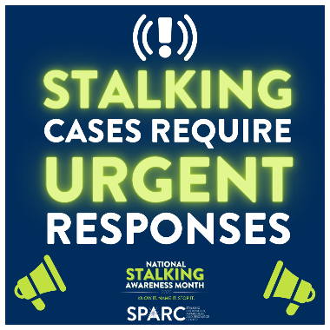 | Again and again, stalking cases are plagued by a lack of urgency and a misperception that “no one is getting hurt.” Stalking is a traumatic and violent victimization that requires an immediate and comprehensive response. #NSAM2023 #KnowItNameItStopIt
31 | Tues | 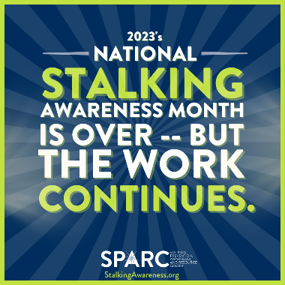 | Stalking survivors need our attention and help every day. Thank you for making #NSAM2023 a success, and please continue to be a voice for stalking victims and survivors in your work throughout the year! #KnowItNameItStopIt

